Quiz 2 ***(CSE331L.7 – Asif Ahmed Neloy_Summer’20)***

Department of Electrical and Computer Engineering

School of Engineering and Physical Sciences

North South University, Bashundhara, Dhaka-1229, Bangladesh

*Time 20 minutes, Marks 20 (You need to answer all questions).*

***Name –Hosne Ara***

***ID –1632267642***

1. **Write a program in Assembly language that will adds the even index values from an Array of Size 20.**

**org 100h**

**a DB 20h DUP<1,2>**

**MOV BX, 20**

**INC BX**

**MOV BX , 35**

**MOV DI , 12**

**LEA SI , [BX+DI]**

**Ret**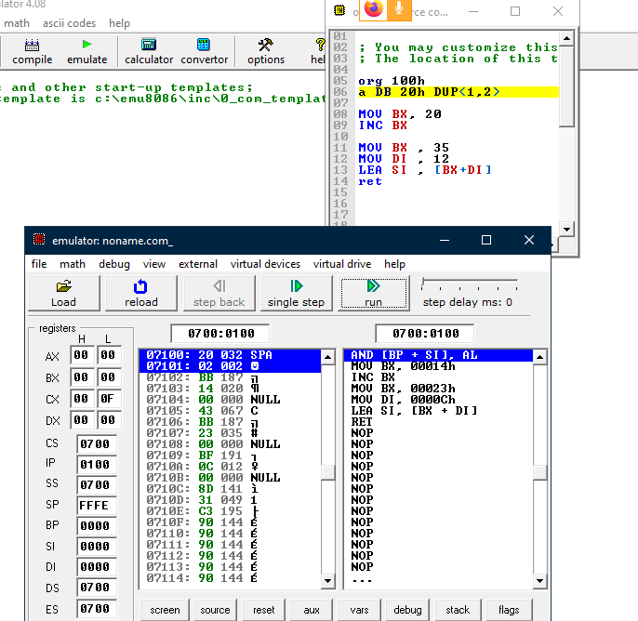

**End**